**Technical Career Education Private Limited**

5th floor, Sahyadri Campus, Adyar, Mangalore 575007



**Hybrid Course on Embedded System**

**PROJECT REPORT**

**2023 - 24**

**Project Title: ‘Energy Usage Optimizer’**

Submitted by:

|  |  |
| --- | --- |
| **Abhishek Naik** | **4SF22EC002** |
| **Apoorva Nagekar** | **4SF22EC010** |
| **Simran Shaikh** | **4SF22EC104** |

Institution:



**Sahyadri College of Engineering and Management**

Adyar Mangalore 575007

**CONTENTS**

**Project Overview**

1. **Introduction**

1. **Problem Statement**

**3. Solution**

3.1 Ideation

3.2 Prototype

**4. Conclusion**

**5. References**

**Project Overview**

|  |  |  |
| --- | --- | --- |
| Problem Statement | Energy Usage Optimizer | |
| Working Prototype  *(Drive Video Link)* | <https://drive.google.com/file/d/1utgZ8FzZWT5ww01nQFh8gZbqMAj_KENX/view?usp=sharing> | |
| Final Presentation *(Link)* | <https://drive.google.com/file/d/1QbTR0qc4ea9qwnUJU56QC_AWf1LmzQjl/view?usp=sharing> | |
| Relevant Photos/ Media  *(Drive Folder Link)* | <https://drive.google.com/drive/folders/1cFspwKYqgUQGKpZtbTIGnAFq878wTVHl?usp=drive_link> | |
| Class/ Section | 6sem/A | |
| Team Members | Name | USN |
| Abhishek Naik | 4SF22EC002 |
| Apoorva Nagekar | 4SF22EC010 |
| Simran Shaikh | 4SF22EC104 |

1. **Introduction**

In an era of rapid technological advancement and increasing dependence on electrical appliances, energy consumption has become a critical concern. With rising electricity tariffs and growing environmental awareness, efficient management of energy usage is more important than ever. However, in most households, offices, and small businesses, there is little to no visibility into how much electricity each appliance consumes on a day-to-day basis. As a result, users often overlook wastage and inefficient usage patterns, leading to inflated electricity bills and unnecessary energy consumption.

The global push for sustainable energy practices demands smart, accessible tools that can help end-users understand and optimize their power usage. While industrial energy monitoring systems exist, they are often expensive, complex to install, and not suitable for everyday consumers or small-scale settings. There exists a clear gap in the market for a simple, affordable, and real-time energy monitoring solution.

This project, titled Energy Usage Optimizer, is designed to address this gap by providing a low-cost, user-friendly system for monitoring and controlling electrical energy usage. By leveraging the capabilities of the ESP32 microcontroller, the system collects data on current, voltage, and power, and sends it to the BlinkIOT cloud platform for visualization. The system not only enables real-time monitoring but also provides remote control features via relay modules and cloud commands.

The goal is to empower users with greater awareness and control over their energy consumption, reduce waste, and promote energy-efficient habits. This system is especially suitable for homes, hostels, schools, or rural electrification setups, where managing electricity usage effectively can lead to significant cost savings and improved sustainability.

1. **Problem Statement**

Electricity is a vital resource in daily life, powering everything from household appliances to critical systems in industries. However, despite its importance, most consumers remain unaware of their actual energy consumption patterns. In typical residential and small commercial environments, users receive only a cumulative monthly electricity bill, which provides no insight into which appliances consume the most power, when peak usage occurs, or how to reduce unnecessary consumption.

The core problems identified are:

* **Lack of Granular Data**: Most users cannot monitor individual appliance consumption in real time. This limits their ability to make informed decisions about reducing power usage.
* **Unawareness of Energy Wastage**: Appliances may be left running unnecessarily (e.g., fans, lights, or air conditioners), especially during off-peak hours or when not in use, contributing to significant energy waste.
* **No Low-Cost Real-Time Monitoring Solutions**: Existing energy monitoring systems are often expensive, proprietary, and difficult to set up for common users. This makes them inaccessible to households, educational institutions, and small businesses.
* **Manual Control**: Without automation or remote control, appliances cannot be managed proactively. This results in missed opportunities to save energy when thresholds are crossed.
* **Lack of Intelligent Feedback**: Users do not receive optimization tips or feedback based on usage patterns, which could help them manage consumption better and lower costs.
* **No Integration with Modern IoT Platforms**: Most small-scale setups do not take advantage of cloud-based monitoring or smart dashboards that offer historical trends and remote insights.

1. **Solution**

To address the challenges of inefficient energy monitoring and lack of control in small-scale environments, the Energy Usage Optimizer offers a smart, low-cost, and user-friendly solution. The system is designed to measure the power consumption of connected appliances in real time and provide users with meaningful insights through cloud-based dashboards. It also allows for automated and manual control of appliances to minimize unnecessary usage.

The core of the solution is an ESP32 microcontroller, chosen for its integrated Wi-Fi capabilities and efficient processing. This microcontroller gathers data from voltage and current sensors, calculates real-time power consumption, and transmits it to the BlinkIOT cloud platform, where users can view live graphs and historical trends.

Additionally, a relay module is used to control appliances remotely—either through user commands or automated logic based on power thresholds. This makes the system interactive, smart, and responsive to user-defined conditions.

**3.1 Ideation**

The idea for the Energy Usage Optimizer stemmed from observing common scenarios in households, hostels, and small businesses where:

* Appliances are left running unattended.
* Users receive high electricity bills without knowing the cause.
* There is no easy way to track or control consumption.
* Energy wastage often goes unnoticed due to lack of feedback.

We wanted to build a solution that:

* Helps users understand their energy usage habits.
* Enables real-time monitoring without technical complexity.
* Automates control of appliances when usage exceeds safe or defined limits.
* Uses readily available, affordable components and open platforms.
* Can be scaled for multiple devices and adapted for smart homes or institutions.

Key design decisions during ideation:

* Select ESP32 for its Wi-Fi and sensor support.
* Use ACS712 for current sensing and a voltage sensor module.
* Integrate BlinkIOT to avoid building a backend from scratch.
* Make the system modular so more sensors or relays can be added later.

**3.2 Prototype**

A working prototype of the Energy Usage Optimizer was successfully built using basic electronic components and open-source tools. The system was developed on a breadboard, powered via USB, and programmed using the Arduino IDE.

**Main Features Implemented:**

* **Voltage and Current Sensing**:  
  Using an ACS712 current sensor and a standard voltage sensor, the system continuously captures electrical parameters.
* **Power Calculation**:  
  The ESP32 calculates power consumption using the formula P = V × I, updated in real time.
* **Wi-Fi & Cloud Connectivity**:  
  Real-time data is sent to the BlinkIOT cloud, where it is visualized through live graphs and charts.
* **Dashboard Access**:  
  Users can log in to the BlinkIOT dashboard from their phone or laptop to monitor usage from anywhere.
* **Appliance Control via Relay**:  
  A relay module allows the system to turn appliances ON or OFF based on thresholds or user commands from the cloud.
* **Safety and Alerts (Optional)**:  
  The system can be extended to trigger buzzer alerts or send notifications when abnormal usage is detected.

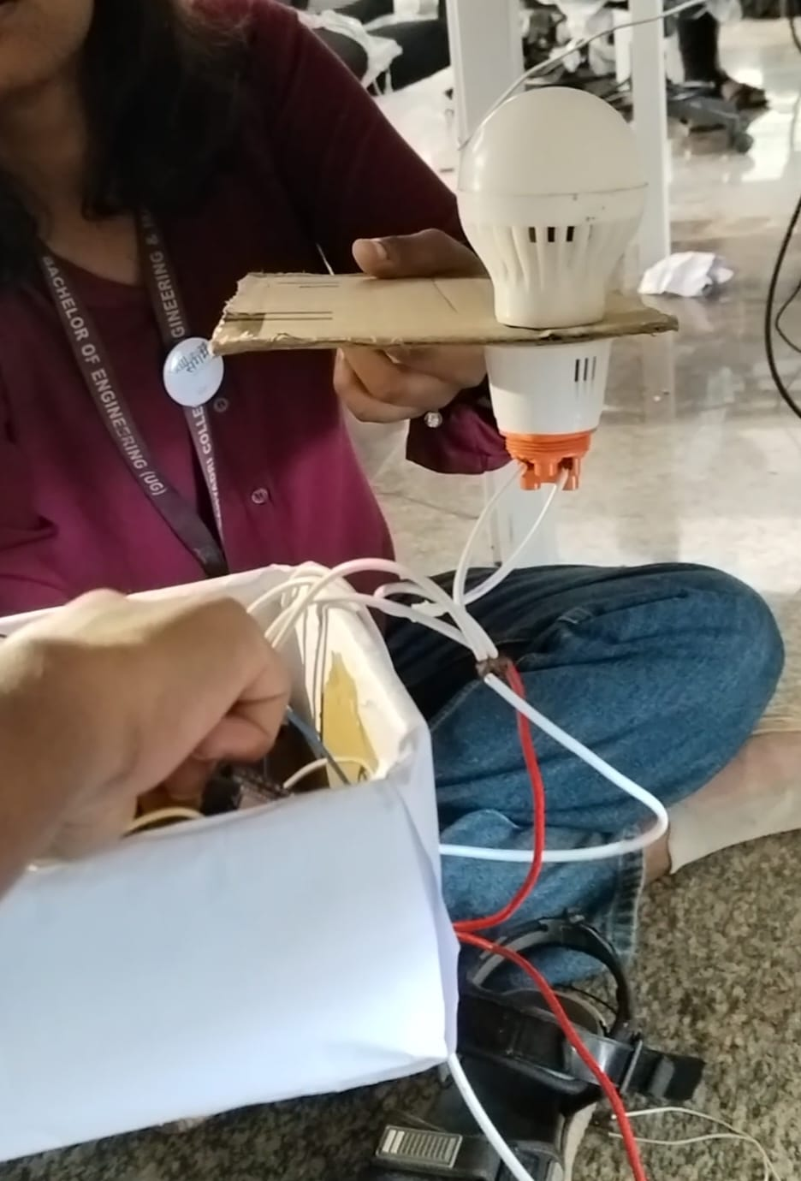 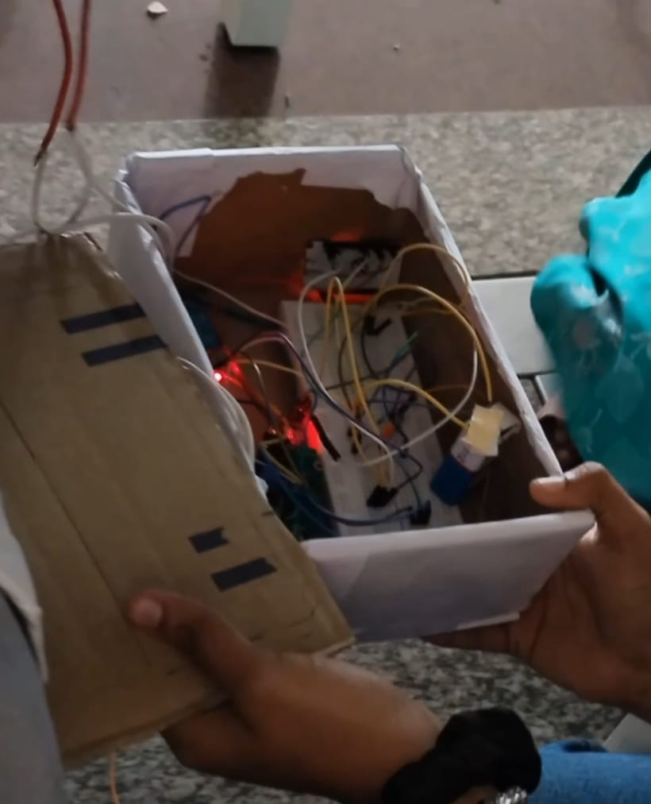

1. **Conclusion**

The Energy Usage Optimizer project successfully demonstrates how affordable hardware and open-source platforms can be combined to create a smart, real-time energy monitoring and control system. By using the ESP32 microcontroller, current and voltage sensors, and integrating with BlinkIOT, the system enables users to gain full visibility into their energy consumption patterns while providing tools to control and optimize usage.

The prototype not only tracked voltage, current, and power accurately but also allowed remote switching of appliances through a relay, making it a practical and scalable solution for homes, hostels, schools, and small businesses. The system’s real-time dashboard empowers users to make informed decisions, reduce wastage, and ultimately lower electricity bills.

With the flexibility to expand into mobile app control, AI-based optimization, and integration with smart grids, this project lays a solid foundation for a future-ready, smart energy management system. It proves that impactful solutions can be both low-cost and highly effective when designed thoughtfully and implemented with purpose.